E-Health for All: A User-Centered Telemedicine System

An Undergraduate Research Paper
Presented to the Faculty of
College of Computer Studies
Naga College Foundation, Inc.
Naga City

In Partial Fulfillment of
the Requirements for the Degree
Bachelor of Science in Information Systems

Alinday, Mark Joseph M.
Bruzo, Ian
Narvato, Dominnica SL.
Paraiso, Kristine Carla I.
Villamer, EJ Andrei J.

2027

1 Introduction
Healthcare access remains one of the most persistent global inequalities, with limited specialist availability and inadequate infrastructure keeping millions from critical care. The World Health Organization estimates that half of the global population lacks access to essential health services, with rural communities disproportionately affected [66], leading to delayed diagnoses and preventable deaths. Telemedicine presents a promising solution by delivering healthcare across distances, connecting remote patients with specialists without requiring travel and making scarce resources available to underserved populations.
In the Philippines, these challenges are especially severe. The country's geography and urban concentration of medical specialists leave rural populations with limited healthcare options. In response, the Philippine government and health institutions have begun embracing telemedicine to broaden coverage. The National Telehealth Center has launched SMS and web-based platforms connecting rural patients with specialist consultations [25], [59], and various health institutions have adopted electronic medical records to improve continuity of care across facilities [36], [40].
Despite these efforts, significant barriers persist. Poor transportation infrastructure hinders facility access, particularly during emergencies and follow-up care. Unreliable internet connectivity, limited computing resources, and low digital literacy among both patients and healthcare workers further compound these challenges [1], [46]. Existing telemedicine initiatives, while promising, remain fragmented and rarely address the unique technological constraints and cultural context of rural Filipino communities [49], [51].
This research seeks to bridge these gaps by developing an integrated telemedicine platform specifically designed for the selected rural barangays The platform combines three components, a comprehensive doctors' database, a patient records management system, and an appointment scheduling system into one user-friendly interface accessible to users with different levels of digital literacy.
This initiative aligns with multiple UN Sustainable Development Goals: good health and well-being (sdg3), by improving healthcare access and quality. it supports industry, innovation, and infrastructure (sdg9), by demonstrating how technology can address healthcare infrastructure gaps in underserved areas. it advances reduced inequalities (sdg10), by examining how digital health solutions reduce disparities in healthcare access across different populations and socioeconomic groups.
Telemedicine Adoption and Implementation
Telemedicine, the delivery of healthcare services using information and communication technologies, has emerged as a vital solution for healthcare access issues in isolated and underserved communities. Telemedicine allows healthcare providers to assess, diagnose, and treat patients in remote areas by utilizing telecommunications technology to effectively connects medical experts with populations that have limited access to healthcare facilities. It has shown great promise in overcoming healthcare access issues in rural communities around the world.
Research shows that telemedicine consultations promote better clinical decision-making, reduce unnecessary patient transfers, and increase the chances of local admissions instead of costly transfers to far-off hospitals [30], [27]. These advantages apply to many medical fields, from primary care to specialized areas like neurology and emergency medicine [15].
However, the pandemic highlighted the shortcomings of telemedicine: access services at lower rates [10],[21]. Digital literacy among older adults and low-income individuals [1],[46], equal access concerns [16],[12],[6], implementation costs and maintenance [43],[9], infrastructure issues [31],[48],[62]., and data security and patient privacy concerns [41].
On the one hand, communities with integrated systems achieve better health outcomes for managing chronic diseases compared to those that use fragmented record-keeping [32]. Patient satisfaction with telemedicine in the Philippines shows encouraging trends [32],[39]. Even senior citizens, increasingly accepted remote consultations [7]. The University of the Philippines Health Service successfully used tailored electronic medical records systems in various settings during COVID-19, ensuring continuity of patient care despite mobility restrictions [36],[59]. Thorough assessments show considerable progress in adoption over time, although significant gaps between different types of facilities and locations persist [3],[38].
Successfully implementing telemedicine requires careful adjustments to local circumstances. Detailed analyses reveal Philippines-specific barriers like governance issues, unclear licensure requirements, unresolved liability problems, and vague reimbursement mechanisms that hinder healthcare provider involvement [25],[51]. Healthcare technology must consider local cultural practices, language preferences, and health-seeking behaviors to ensure meaningful user acceptance in diverse Filipino communities [49]. Creating user-friendly systems is crucial for sustained adoption rather than leaving behind abandoned pilot projects [63].

Patient Information Management System
Patient information management involves the organized collection, storage, and use of health data to support clinical decision-making and ensure continuity of care. Electronic Medical Records (EMR) systems digitize patient health information, enabling providers to access complete histories, track treatments, identify medication interactions, and coordinate care across specialties. This is especially critical in rural and underserved areas where access to prior care records is limited.
EMR systems significantly improve care coordination, with integrated communities achieving better chronic disease outcomes compared to those with fragmented records [33], [19]. However, while basic adoption rates are high, comprehensive implementation remains lower in rural facilities despite recognized benefits [12], [6]. Technical, organizational, and workflow barriers continue to hinder smooth information sharing [48], [3], [38], and digital literacy gaps among older adults and low-income individuals require targeted design and training interventions [1].
Data security and patient privacy are foundational to EMR trust, requiring encryption, access controls, and audit trails [41]. Integrated systems reduce administrative burdens and improve care delivery [45], [56], [26], while predictive models using patient data enable targeted interventions and better resource allocation [17], [13], supporting a shift toward proactive, preventive primary care [11].
In the Philippines, EMR adoption shows both progress and challenges. COVID-19 visibly impacted system usage in rural health facilities [2], yet implementation improved clinical decision-making and reduced medication errors compared to paper systems [40]. Sustained adoption is linked to training, technical support, and gradual workflow integration rather than rapid rollouts [28], though research representation across specialties, settings, and facility types remains uneven [14]. The absence of centralized provider databases causes referral delays and disjointed care [60], while comprehensive physician databases with specialization and scheduling details enhance diagnostic workflows [53]. Keeping such databases accurate remains challenging, necessitating automated verification and validation processes [35].
Appointment Scheduling in Healthcare
Appointment scheduling systems are essential to healthcare delivery, coordinating patient needs, provider availability, and facility resources. Well-designed systems reduce waiting times, lower missed appointments through automated reminders, improve provider productivity, and ensure urgent cases receive prompt attention. In rural settings, where patients face long travel distances and transportation barriers, efficient scheduling is especially critical for maintaining access and treatment adherence.
Digital scheduling significantly reduces no-show rates compared to offline booking, with automated reminders proving particularly effective [45]. AI-driven tools further improve efficiency by predicting non-attendance and optimizing resource allocation [56], while open-access scheduling reduces no-shows by offering same-day or next-day appointments [26]. Predictive models incorporating patient demographics and appointment history identify high lead time and prior missed appointments as the strongest predictors of non-attendance [17], [13]. Integrated systems also improve patient flow and reduce waiting area congestion in underserved facilities [65], supporting broader proactive primary care initiatives through timely referrals and fewer missed appointments [11], [35].
In the Philippines, digital appointment management in rural health centers has shortened waiting times and reduced missed appointments through better time slot management and automated reminders [50]. However, rural contexts require flexible approaches, as rigid scheduling is ineffective where patients face unreliable transportation or inflexible work schedules. Systems must therefore incorporate easy rescheduling options and reminder methods that function without internet access [37].
Synthesis of the State-of-the-Art
The detailed collection of works and studies offered valuable insights into the topic. These studies backed their claims with relevant data and detailed information. This section will provide a brief overview of the reviews of relevant literature.
Telemedicine has emerged as a viable solution to geographic barriers, improving clinical decision-making, reducing unnecessary transfers, and expanding specialist access [15], [30], [27]. However, persistent challenges remain, including infrastructure limitations, digital literacy gaps, data security concerns, and Philippines-specific barriers such as unclear licensure, liability, and reimbursement mechanisms [25], [41], [46], [51]. Despite these, large-scale pilots in the Philippines demonstrate feasibility across diverse communities, with patient satisfaction showing encouraging trends even among senior citizens [7], [32], [39], [59]. Successful adoption requires culturally sensitive, user-centered design tailored to local contexts [49], [63].
Patient information management systems significantly improve care coordination and clinical outcomes, yet comprehensive EMR implementation remains lower in rural facilities [6], [12]. Workflow barriers, digital literacy gaps, and data security concerns continue to hinder full adoption [1], [3], [38], [41]. In the Philippines, gradual integration supported by training and technical assistance yields better sustained adoption [28], while the absence of centralized provider databases causes referral delays and fragmented care [53], [60].
Appointment scheduling systems directly reduce no-show rates, improve patient flow, and support proactive primary care [11], [45], [56]. Predictive modeling and AI-driven tools further optimize resource allocation [17], [13], [56]. In Philippine rural health centers, digital scheduling has measurably shortened waiting times [50], though flexible, offline-capable systems are essential given transportation and connectivity constraints [37].
Across all three areas, the literature consistently points to the need for an integrated, context-sensitive platform that unifies patient records, provider information, and appointment scheduling precisely the gap this research addresses.
Gap Bridged by the Study
This study addresses important gaps in rural healthcare delivery by creating an integrated telemedicine platform specifically for rural barangays in Naga City. Existing telemedicine systems often look at patient management and appointment scheduling separately. This research offers a more complete solution by combining a doctors' database, a patient records management system, and appointment scheduling into one platform. It addresses the unreliable internet connectivity that is common in rural areas. Healthcare workers can keep entering data and accessing patient information even without internet access. Once the connection is restored, the system syncs automatically. By bringing these features together in one practical system designed for resource-limited settings, this research shows how telemedicine solutions can be adapted to meet the real technological, infrastructure, and cultural challenges faced in rural healthcare.

Theoretical Framework
This study is grounded in three (3) key theories that collectively support the development of the proposed telemedicine system using the Diffusion of Innovations (DOI) Theory (Rogers, 2020), the Task–Technology Fit (TTF) Theory (Goodhue & Thompson, 1995), and the Technology Acceptance Model (TAM) (Marikyan and Papagiannidis, 2024). Together, these theoretical foundations inform the system’s design, usability considerations, and adoption potential within rural healthcare settings.
According to Goodhue and Thompson (1995), the Task Technology Fit (TTF) Model posits that technology will be adopted and effectively utilized when its functionalities align with the specific tasks that users are expected to perform. The model argues that a strong “fit” between task requirements such as information retrieval, decision-making, communication, and documentation and the capabilities of the system results in improved individual performance and greater likelihood of continued system use. When technology supports the user’s workflow and reduces the effort required to complete essential activities, it becomes more valuable, usable, and integrated into daily operations. This model is relevant to the proposed telemedicine platform because its success depends on how well its features such as patient record management, scheduling, and remote consultation support match the operational needs and constraints of rural healthcare providers, ultimately influencing system utilization and performance outcomes.
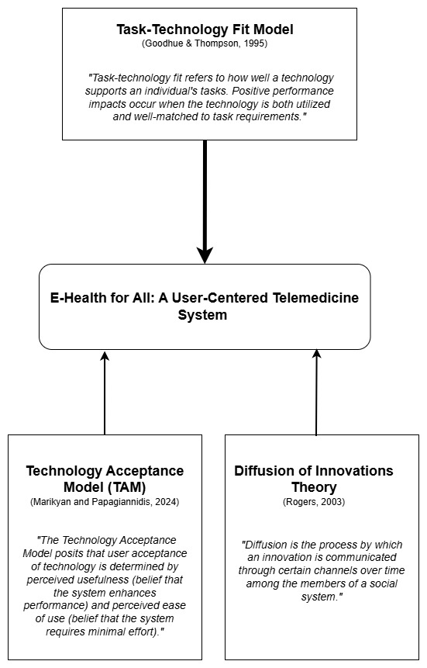
Figure 1: Theoretical Paradigm
The diagram illustrates the theoretical foundations guiding the development of the E-health for All telemedicine system for improving access in rural communities.

According to Rogers (2020), the Diffusion of Innovations (DOI) Theory explains how new ideas, practices, or technologies spread through a population over time. It emphasizes understanding the characteristics of innovations and the social processes that influence adoption rates among different groups. The referenced author states that this theory focuses on five key attributes that determine adoption: relative advantage, compatibility, complexity, trialability, and observability. It highlights the role of communication channels, opinion leaders, and social systems in facilitating or hindering the spread of innovations. In this study, it will guide the implementation strategy for the telemedicine platform in rural communities. The strategy will consider social dynamics and adoption patterns when introducing the system. The researcher can identify early adopters, such as progressive healthcare providers and influential community health workers, show its benefits to others, and help normalize its use in the community. By understanding the stages of adoption (awareness, interest, evaluation, trial, and adoption) and designing interventions for each stage, the system can gain wider acceptance and sustained use among diverse rural populations with different levels of technology readiness.
According to Marikyan and Papagiannidis (2024), the Technology Acceptance Model (TAM) asserts that two significant factors to a user’s intention to adopt a technology: perceived usefulness and perceived ease of use. Perceived usefulness refers to the extent to which an individual believes that a technology enhances task performance and overall productivity, while perceived ease of use pertains to the belief that the system can be operated with minimal physical and cognitive effort. These perceptions shape a user’s behavioral intention and ultimately influence actual system acceptance and usage. TAM has been extensively utilized across disciplines to assess user acceptance and inform the iterative development of systems that prioritize accessibility and usability. TAM is highly relevant to the proposed telemedicine platform because its adoption depends on users especially those in rural areas with varying levels of digital literacy perceiving the system as beneficial, simple to navigate, and supportive of their essential healthcare tasks.
Conceptual Framework
The enhanced system paradigm is the approach utilized in the conceptualization of this study. The input came from various sources to gain a complete understanding of rural healthcare needs and readiness for technology, such as document analysis of health records, observations of healthcare-seeking behaviors and travel times, surveys evaluating user satisfaction and technology skills, and interviews gathering in-depth information about access challenges and provider readiness for telemedicine services. The processes involved includes, systems analysis and specification for system design, functional testing to ensure adherence to system requirements, usability testing to ensure the system meets the user needs, and acceptability to validate the system feasibility for deployment. The study’s output is a web application with the following features like computer vision, security, authentication, verification, patient check-up history, Qr code security, by using the system it is expected to improve efficiency, achieve fewer documentation and smoother, admin shorter waiting times, through better appointment, enhance user satisfaction, and improve data security of patient information. The continues feedback mechanism will ensure iterative refinement of the system to remain user friendly, operational and align with rural healthcare.
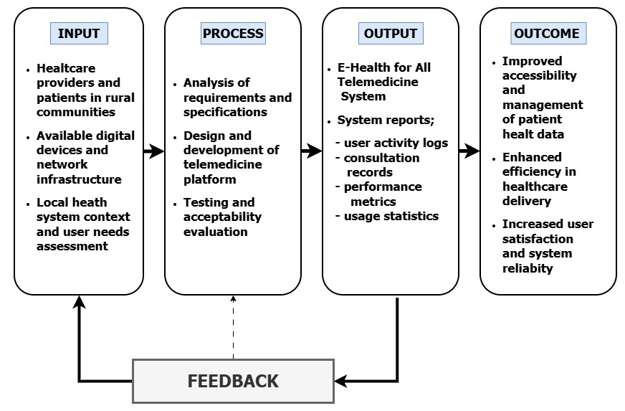

Figure 2: Conceptual Paradigm
The organization of concepts on the Input-Process-Output-Outcome (IPOO) model illustrates the systematic development and implementation of the E-Health for All telemedicine system for rural healthcare delivery.
Statement of the Problem
This study aims to address the problem in healthcare accessibility of rural populations. Specifically, this study seeks to answer the following questions:
- What are the current practices of rural healthcare providers in rural populations with respect to:
- Patient records management
- Doctor scheduling
- Appointment systems
- What are the challenges encountered in the current system?
- Patient records management
- Doctor scheduling
- Appointment systems
- What system can be designed to address the challenges encountered?
- What is the level of acceptability of the system in terms of:
- Usability
- Reliability
- data security
Assumptions
The research study is anchored on the following key assumptions:
- Rural healthcare providers in Panicuason, Naga City have specific practices for managing patient records, scheduling doctors, and handling appointments.
- There are challenges with the current systems for managing patient records, scheduling doctors, and setting up appointments in rural healthcare facilities.
- A user-centered telemedicine platform can be designed and developed to tackle these challenges in the current healthcare delivery system.
- The rural healthcare providers and clinic staff are ready to accept and shift to the current manual practice towards the proposed user-friendly telemedicine platform and digital records management system.
Scope and Delimitations of the Study
This study addresses healthcare accessibility problems in rural populations, specifically focusing on rural healthcare providers and their patients. The objective of this study is to design a user-friendly online system to improve the management of the patient records, aid in scheduling the providers and assist in arranging the appointments to enable the healthcare delivery to be more effective in rural environments.
The study will be conducted in Barangay Panicuason, Naga City covering the entire design and development of prototype for telemedicine functions, including digital patient health profiles, clinical encounter documentation, monitor vital signs, maintain medication monitoring, access medical history and posting tools for manage the patients and automatic generate appointment supported by integrated doctor database. The subjects were selected among rural health units' staff, which consisted of physicians, nurses, midwives, and administrative personnel. The platform is a web application that uses a MySQL database and PHP, HTML, CSS, and JavaScript with XAMPP local server for testing. It works on Windows 10/11, macOS, Linux and Android devices offline. The system only supports Android smartphones running version 8.0 or higher with a minimum screen resolution of 720x1280 pixels.
However, this study is limited only to Barangay Panicuason and does not extend to other rural or urban healthcare facilities, which narrows the generalizability of the findings. The system does not contain some high-level features like lab integration, payment and billing modules, pharmacy management, patient portals, or iOS compatibility. The evaluation we present here includes only the first-time development and rapid system feedback, not long-term performance, cost effectiveness, or continuation in place. Factors such as instability of the internet, power outages, different digital literacy levels, and changes in healthcare policies are also beyond the study’s scope.
Significance of the Study
This research is important for various stakeholders and helps improve healthcare equity and digital health innovation. The following are the key beneficiaries of this research:
Patients in Rural Communities. Rural residents will see the most direct benefits by avoiding expensive trips to urban medical facilities for routine check-ups. Patients save money on transportation and time spent traveling, allowing them to access healthcare without disrupting work or family responsibilities. Digital medical records give patients more health information, while the appointment system cuts down on waiting times. For patients with chronic conditions, the platform provides ongoing care without the need for long-distance travel, leading to better health outcomes.
Rural Healthcare Providers. Healthcare providers in rural health units will benefit from automated patient record management and better appointment scheduling. Digital patient records allow for quicker clinical decisions, especially during emergencies. The integrated doctors' database makes it easier to refer patients to specialists and coordinate care. Providers can conduct remote consultations, serving more patients efficiently while reducing administrative tasks and documentation errors.
Community Health Workers. Frontline workers gain better capabilities through quick access to patient information for consultations and emergencies. The system reduces paperwork, allowing them to focus on direct patient interaction and health education. Workers can help facilitate remote consultations for patients uncomfortable with technology and track health trends to spot emerging issues early. Improved documentation tools enhance their professional skills and recognition within the healthcare team.
Health Administrators and Local Government Officials. Administrators get valuable data on how telemedicine helps fill gaps in rural healthcare, supporting better resource allocation decisions. The platform's reporting features allow tracking of disease prevalence, service use, and community healthcare needs. Metrics on patient volumes and health outcomes help assess the effectiveness of programs. This research provides a model for digital health initiatives that can work in other rural areas, showing cost-effective strategies for extending services to underserved populations.
Technology Developers. Technology developers get practical insights into the technical needs and key features that are most important to rural healthcare stakeholders. The research outlines detailed requirements for building systems that can work offline and function well even with unreliable internet access. Developers receive tips on creating mobile-friendly interfaces designed for smartphones that are commonly used in rural areas rather than high-end computers. The study also addresses solutions for infrastructure issues, including ways to optimize low bandwidth, data syncing strategies, and system performance in resource-limited situations. The research gives evidence-based advice on balancing system capabilities with ease of use. This helps developers create strong yet user-friendly platforms for individuals with limited tech experience. The study shares real-world testing results and user feedback, which can guide development processes and improve future systems.
Academic Researchers. The research community benefits from clear frameworks for creating easy-to-use digital health solutions for rural areas with limited resources. This study offers evidence on effective design methods and implementation techniques specifically made for resource-limited settings. This includes strategies for adapting to the cultural needs of people with different levels of digital literacy. The research supplies validated tools for measuring how acceptable telemedicine is, which can be used in similar studies. Findings add to the growing knowledge on developmental-descriptive research methods in digital health innovation. The study fills important gaps in literature about integrated telemedicine platforms. It provides evidence-based suggestions for developing comprehensive systems instead of focusing on separate components.
Definition of terms
This section provides clear and precise definitions of key terms used throughout the study, both operationally and conceptually.
E-health. E-health, also called electronic health or digital health, refers to using information and communication technologies in healthcare delivery (World Health Organization, 2023). This includes telemedicine, electronic medical records, and digital health platforms. It covers any health-related service or information provided electronically through the internet, mobile devices, and telecommunications systems to improve healthcare access, quality, and efficiency.
E-health for All. E-health for All is the main principle and title of this research. It highlights the need for equal access to digital health technologies for everyone, regardless of where they live, their income, or their tech skills (Kepper et al., 2024). In this study, it means committing to creating inclusive, user-friendly telemedicine solutions aimed specifically at rural communities in Naga City.
Telemedicine. Telemedicine is the delivery of healthcare services and clinical information through communication technologies (Li et al., 2025). This approach helps overcome geographical barriers and improves access to medical services for patients in remote areas. In this study, it refers to the proposed remote healthcare delivery system in Naga City.
User-centered design. User-centered design is a development methodology that focuses on the needs, preferences, and limitations of end-users during the design process (ISO 9241-210:2019). It involves actively engaging users in defining requirements, evaluating prototypes, and refining systems. In this study, it refers to the participatory design approach used to create the telemedicine platform for rural patients and healthcare providers in Naga City.
Rural healthcare. Rural healthcare means providing medical services in isolated or underserved areas (Centers for Disease Control and Prevention, 2025). These locations often lack adequate healthcare infrastructure, have few medical specialists, and face significant barriers to quality health services. In this study, it refers to healthcare in the barangays of Naga City outside the urban center who encounter challenges like long travel distances to medical facilities, limited specialist consultations, and difficulties in accessing timely medical care.
Telehealth platform. A telehealth platform is a digital health ecosystem that combines various functions (S-Pro, 2024). It includes provider directories, patient information systems, and scheduling tools to facilitate remote healthcare delivery and improve care coordination. In this study, it refers to the web-based system developed for Naga City. This system integrates three main components: the doctors' database, electronic medical records management, and appointment scheduling into a single interface designed to improve healthcare access for rural populations.
Healthcare accessibility. Healthcare accessibility refers to how easily individuals can obtain necessary health services on time. It considers factors like physical availability, geographical proximity, economic affordability, and organizational fit. In this study, it addresses how rural residents of Naga City can access medical consultations, specialist services, and health information through the telemedicine platform. This technology removes geographical and time barriers that previously hindered timely healthcare use.
2 METHODOLOGY
This section outlines the research methodology. It covers the research design, participants, location, data collection methods and tools, ethical considerations, statistical analysis, project timeline, and validation methods to ensure the reliability of the findings.
Research Design
This study will adopt a developmental-descriptive qualitative research design. This approach was chosen to describe and understand the current healthcare access challenges in rural communities and to identify how telemedicine can offer solutions. The descriptive method will help document the current state of healthcare delivery and accessibility. Additionally, it will provide detailed insights from those who would use the telemedicine system daily.
Data will be collected through interviews, observations, and surveys. This provide understanding of how rural residents, healthcare providers, and community health workers experience the current healthcare access situation. The study will also include documentary analysis, where the researchers will review documents and observe how healthcare services are accessed in these communities. By combining different data collection methods, the researchers can form a complete picture of the challenges and needs of all stakeholders.
The study has four main phases. Phase 1 is the preparation phase, where approvals are obtained and the research tools are prepared. Phase 2 is the assessment phase, during which we will observation and documenting of the current healthcare access situation are conducted. Phase 3 is the data collection phase, where the researchers will interview participants and gather their feedback. Phase 4 is the analysis phase, where all the information will be organized to make recommendations. This phased approach will help ensure that we collect data systematically and capture important information.
Software Methodology
The software development methodology for the E-health for All application will follow an iterative and incremental approach, combining elements of the Agile methodology. We suggest using an Agile development method because it is flexible and allows for continuous user feedback. Agile operates in short cycles where developers create small parts, present them to users, gather feedback, and make improvements before proceeding.
Development Phases. The development will start with a list of all necessary features based on our research. Developers will create simple mockups and share them with healthcare providers and rural residents to ensure usability. Then programming will begin in phases: first, user registration and doctor database; second, appointment scheduling; third, video consultations and patient records; fourth, prescription management. Each phase will be tested for functionality and user-friendliness.
Testing Process. Testing will occur before launch. Developers will test the platform on different devices and internet speeds. Healthcare providers will conduct mock consultations, while rural residents will test the mobile app. Security testing will make sure that patient data is protected.
Pilot Implementation. Pilot testing in selected barangays will identify issues before the full rollout. Training will be provided to healthcare providers, community health workers, and rural residents. User manuals and video tutorials in local languages will be available for reference.
System Design
The system design process employed several modeling techniques such as use case and system workflows to map user interactions and operational processes. These techniques directly captured the functional requirements, user actions, and step-by-step procedures within the system. This ensured a thorough understanding for designing a robust and efficient telemedicine platform.
Use Case
The use case diagram in the study showed the specific interactions between patients, healthcare providers, and system administrators with the system. It defined the actions between these actors and the use cases, along with the functional requirements. The use case model for this study was shown in Figure [3].
In the use case diagram, there were three actors: patients, doctors, and system administrators. All actors can register and log in to the system. Patients and doctors utilize a mobile application, while system administrators access a dedicated website application.
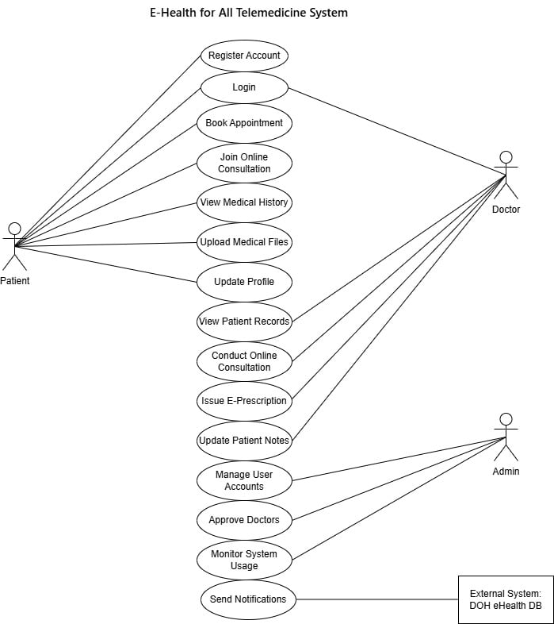
Figure 3. Use Case Diagram

System Workflows
The system workflows illustrate the sequential processes and decision points for key operations within the E-Health for All Telemedicine System. These workflows ensure standardized procedures and guide users through various system functionalities.
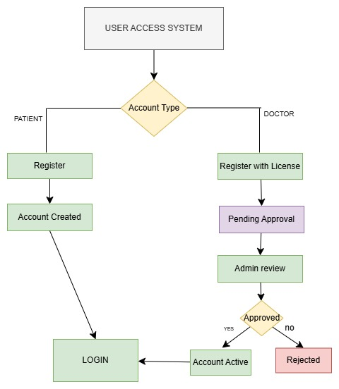

Figure 4. System Workflows

Systems Architecture
The system architecture for the E-Health for All Telemedicine System, shown in Figure [5], integrates three key stakeholders: Healthcare Providers (Doctors), Rural residents and System Administrators.
Since our research focuses on evaluating healthcare access issues in communities and developing a plan for telemedicine, we provide recommendations on what the telemedicine platform should include and how it should work. Figure 5. illustrates the architecture of the E-Health for All telemedicine system, showing the flow from user interaction through devices, connectivity, application services, integration layer, to data storage.
Our proposed system comprises three main components reflected in the Application Layer of the architecture. First, a web-based platform for healthcare providers includes secure login, patient record management, video consultation feature, and the ability to document symptoms, diagnoses, and prescriptions. The platform generates digital prescriptions and medical certificates through the document service in the integration layer. Second, a mobile application for rural residents allows users to schedule appointments, access medical records, conduct video consultations, receive appointment reminders via SMS service, and access health education information. The app includes emergency contact details for urgent situations. Third, a doctor database and scheduling system maintains provider profiles including specializations, qualifications, availability, and consultation fees.

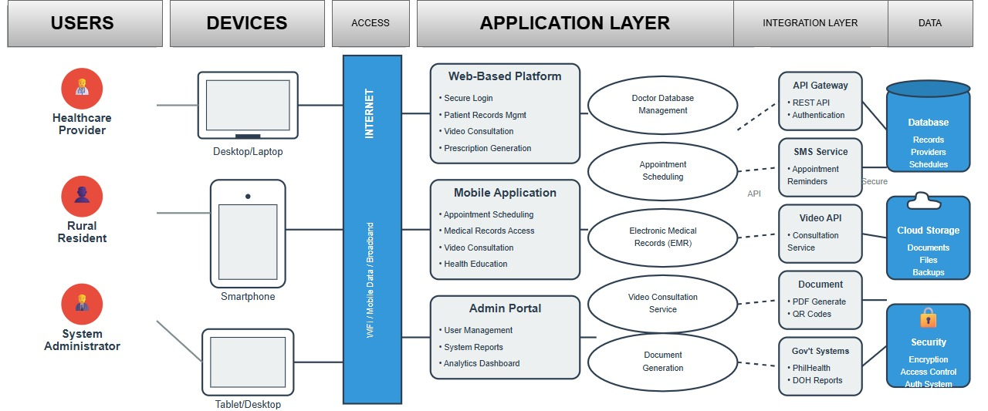
Figure 5. E-Health for All System design Architecture
Population and Sample
The researcher determined the respondents through a systematic selection process based on their direct involvement with rural healthcare delivery at Panicuason Barangay Health Center in Naga City. The participants were selected because they had direct experience with current healthcare delivery practices and would be the primary users and stakeholders of the proposed telemedicine system.
The study involved healthcare providers and staff from Panicuason Rural Health Unit in Naga City. Based on preliminary observation in barangay health center has a total of 11 healthcare personnel consisting of 7 Dental Health Workers (DHW), 1 Midwife, 1 Encoder, 1 Barangay Nutrition Scholar (BNS), and 1 Staff Nurse (SNF). These individuals managed patient records, coordinated healthcare services, and handled appointment systems at the facility. Since there are only 11 respondents, the study will utilize total enumeration as is for sampling procedure for the design of the system. Additionally, the study will include rural community residents of Barangay Panicuason who are the primary users facing healthcare access challenges. These community members will provide critical insights into the daily challenges they encounter when accessing healthcare services. For the rural community residents, purposive sampling will be implemented allowing only the willing to participate will be consulted. Rural residents will be designed using the Slovin’s formula.

Slovin's Formula. To determine the appropriate sample size for rural residents, we will use Slovin's formula:
where:
- n = required sample size
- N = total population of Barangay Panicuason
- e = margin of error (set at 0.05 or 5%)
This formula helps ensure our sample size is adequate to represent the barangay population while maintaining statistical reliability.
Research Locale
The study will be conducted at Barangay Panicuason Rural Health Unit in Naga City, Camarines Sur. Barangay Panicuason is barangay located outside the urban center of Naga City and faced typical rural healthcare challenges including limited specialist availability & equipment, long travel distances to medical facilities, and insufficient healthcare infrastructure to meet community needs.
The Rural Health Unit served as the primary healthcare facility for residents of Barangay Panicuason and surrounding areas. The facility provided basic health services including primary care consultations, maternal and child health programs, immunization services, disease prevention activities, and health education. When specialized care was needed, the facility referred patients to nearby hospitals in Naga City proper or other municipalities, which often required significant travel time and expense for rural residents.
Data Gathering Procedure
This section outlines the methods and tools the researchers will use to capture data, including the insights and perspectives of stakeholders that are essential for this study.
Preparation Phase. This is the first step in establishing formal agreements and obtaining necessary approvals before starting the research. It involves getting approval for preparing formal letters to request permission from barangay officials and local health officers, and creating consent forms for all participants. During the first two weeks, the researchers will coordinate with community leaders, introduce themselves to health workers and residents, and schedule observation and interview dates while considering community schedules to avoid busy times like fiestas or barangay activities.
Document Analysis. This method collects data by examining health records from barangay health stations, existing referral systems, and community health profiles. It adds depth to the data-gathering process by providing evidence of current healthcare access patterns and challenges. This will complement the information gained from observations and interviews. The researchers will analyze types of health complaints commonly addressed, the frequency of referrals to distant facilities, travel time and costs to access healthcare, the availability of medical specialists, and community health statistics.
Direct Observation. This method involves systematically watching and recording healthcare access patterns and challenges in their natural setting. It allows researchers to see firsthand how residents attempt to access healthcare, identify barriers and difficulties, and measure the time and resources needed to reach medical facilities. The researchers will taking detailed notes about healthcare-seeking behavior, timing travel to the nearest clinic or hospital, documenting available transportation options, and observing how health workers currently handle patient consultations and referrals.
Surveys. This method collects information from respondents through standardized questions and response options, usually using paper forms or mobile surveys. It gives respondents a chance to share their views, preferences, and experiences about current healthcare access and their needs for a telemedicine solution.
Interviews. This method gathers information through one-on-one conversations with stakeholders, allowing for deeper exploration of issues and concerns. This approach can capture data that might not appear in surveys or observations and enables the exploration of emerging themes and contextual details. The researchers will conduct individual interviews lasting 30 to 45 minutes with rural residents about their healthcare access struggles, healthcare providers about their willingness to offer telemedicine services and their needs for remote consultation tools, and IT personnel about technology infrastructure and connectivity issues in rural areas.
Data Analysis and Documentation. This is the final phase of processing and interpreting all the collected information to derive meaningful findings and recommendations. This phase involves transcribing interview recordings, organizing qualitative data by themes, computing statistical measures for quantitative data, and creating visual representations of findings. The researchers will devote weeks 10 to 12 to typing all interview notes and recordings, organizing data by themes such as healthcare access barriers, technology readiness, required features, and implementation concerns, counting survey responses, and creating graphs and tables. They will compare findings across different communities to identify common patterns and write the final findings and recommendations based on all the gathered data.
Validation and Testing Methods
To ensure the comprehensive validation and testing of a system quality and reliability.
Functionality Testing. Unit testing verified individual components, with each function tested independently to ensure correct performance. Test cases covered normal inputs, edge cases, and invalid inputs. Integration testing verified module interactions, ensuring data flowed correctly between modules and integrated components worked together.
User Acceptance Testing involved healthcare providers evaluating whether the system met their needs. A checklist validated that requirements were implemented. Participants confirmed that each feature worked as expected and was useful for their work. Sign-off criteria required at least 80 percent feature acceptance. Features falling below this threshold were revised based on feedback.
Performance Testing. Load testing simulated multiple concurrent users, testing the system with 10, 20, and 30 simultaneous users to ensure acceptable performance under typical and peak loads. Response time measurement tracked system responsiveness to user actions, with target response times under 3 seconds for most operations. Offline functionality verification tested data entry and retrieval without internet connection, confirming automatic synchronization upon reconnection.
Security Testing. Access control verification ensured users could only access features appropriate to their roles, with unauthorized access attempts tested to confirm they were blocked. Data encryption validation confirmed sensitive information was encrypted in transit using HTTPS and at rest in the database. Password security was tested to ensure passwords were hashed using strong algorithms. Session management was tested to ensure sessions expired appropriately and could not be hijacked.
Usability Testing. The think-aloud protocol was employed with 5 to 8 representative users. Participants verbalized thoughts while completing tasks as the researcher observed and recorded difficulties, confusions, and errors. Task completion rates measured how many users successfully completed tasks. Time on-task measured efficiency. Error rates counted mistakes made during tasks. Satisfaction ratings gathered subjective impressions after task completion.
Research of the Instrument
This study will use various research instruments to collect accurate and relevant data from participants. These instruments are designed to gather both qualitative and quantitative information to gather specific information that will help us understand the current healthcare access situation and identify what is needed for an effective telemedicine platform.
Interview Guides. Researchers will prepare interview guides for our respondents. For rural residents of Barangay Panicuason, we will ask about their experiences with healthcare services at the barangay health center, the distance they travel to see a doctor or reach hospitals in Naga City, the costs involved in getting medical care including transportation expenses, and the health problems they commonly face. We will also inquire about their access to mobile phones and the internet, their comfort level with technology, and what features they would like in a telemedicine platform. Researchers will ask about current record-keeping systems, data management challenges, internet connectivity at the health center, available technology devices like computers or tablets, specific technical challenges they face, and infrastructure needs for a reliable telemedicine system. All interview guides will include follow-up questions, allowing us to delve deeper into interesting points.
Survey Questionnaires. For rural residents, we will design a questionnaire that asks about their age, household size, and common health conditions. We will also inquire about their satisfaction with current healthcare access using a 5-point scale. Other questions will include how far they travel to see a doctor, how much they spend on healthcare including transportation, how often they delay seeking medical care due to access barriers, their ownership of mobile phones and internet access, and what features they would like in a telemedicine system. For healthcare providers and health workers, the questionnaire will ask about their current workload, their willingness to provide telemedicine consultations, their technology skills, and what support they need to deliver remote healthcare services effectively.
Ethical Considerations
This research will follow strict ethical guidelines to protect all participants and ensure responsible handling of operational data. The following measures will be implemented:
Voluntary Participation: Participation in this study is completely voluntary. No one will be pressured or given incentives that could unduly influence their decision to join. Participants can choose not to answer any question or withdraw from the study at any time without facing any consequences or affecting their access to healthcare services.
Informed Consent: All participants received detailed information about the study before agreeing to participate. This information covered the study's purpose, what participation involved, how data would be collected and used, potential risks and benefits, confidentiality measures, and the right to withdraw at any time without consequences. Participants who agreed to join the study signed an informed consent form.
Parental/Guardian Consent and Minor Assent: For participants under 18 years of age, written parental or legal guardian consent will be obtained before any research involvement. Additionally, minors aged 7-17 years will provide written assent, demonstrating their willingness to participate after receiving age-appropriate information about the study. Both parent consent forms and minor assent forms will clearly explain the study purpose, procedures, and the minor's right to withdraw at any time. Minors may decline participation even if parents have provided consent.
Consent from Barangay Health Workers (BHWs): BHWs who participate in interviews or provide information for the study will sign informed consent forms specifically acknowledging permission to collect and use their personal information, professional insights, and observations about community health needs. The consent form will clarify how their contributions will be used in the research and ensure their personal information is protected according to data privacy regulations.
Privacy and Confidentiality: Individual identities were not revealed without explicit written permission from the participant. Interview recordings and transcripts were stored in password-protected digital files that only the research team could access. Researcher will not photograph or record any actual patient medical records that contain private health information.
Data Protection: All research data according to the Data Privacy Act of 2012 (Republic Act No. 10173). Personal identifiers will be removed from datasets, and survey responses will remain anonymous. Health information discussed during interviews will be kept strictly confidential. After we complete the thesis and any required retention period, we will securely destroy all data.
Minimizing Risk: The research procedures present minimal risk to participants. We will be mindful of participants' time and will travel to their communities to minimize inconvenience. If participants feel uncomfortable during interviews or discussions, especially when discussing sensitive health conditions, we will pause or end the session immediately and provide appropriate referrals if needed.
Cultural Sensitivity: Understanding that rural communities may have unique cultural beliefs about health and healthcare, we will approach all interactions with cultural humility and respect for local practices. We will collaborate with community leaders to ensure our research activities are culturally appropriate and scheduled at convenient times.
Researcher Responsibilities: The research team is committed to maintaining honesty and integrity by accurately recording and reporting all data without fabrication or selective omission. All sources will be properly cited to avoid plagiarism. The research process, including challenges and limitations, will be honestly reported, and findings will be shared with participating communities upon request.
Statistical Tools
This section explains how we will analyze and interpret the collected data to answer the research questions.
Descriptive Statistics.
The study employed descriptive statistical methods to summarize and describe the characteristics of the sample and their responses. The following descriptive statistics will be used; percentage, frequency distribution, and weighted mean.
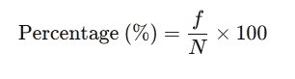
Percentage. To show the proportion of respondents who chose each answer option, we will calculate percentages using the formula:

where:
f = frequency or number of responses for a specific option
N = total number of respondents
For example, if 45 out of 60 rural residents say they want mobile access to health records, the percentage would be calculated as (45/60) × 100 = 75%.
Frequency Distribution. We will create frequency tables displaying how many respondents selected for each response option. For instance, for a satisfaction question with a 5-point scale, the frequency distribution might be presented as:
Table 1. Frequency Distribution
Response Category | Number of Respondents | Percentage
Very Satisfied | 5 | 8.3%
Satisfied | 25 | 41.7%
Neutral | 15 | 25.0%
Dissatisfied | 10 | 16.7%
Very Dissatisfied | 5 | 8.3%
Total | 60 | 100%


Weighted Mean. For Likert-scale items where we want to account for the frequency of each response, we will calculate the weighted mean using the formula:

where:
W = weight or scale value (1-5 for a 5-point Likert scale)
f = frequency or number of respondents who chose that value
N = total number of respondents
Σ = summation symbol
Statistical Treatment of Data
The data gathered will be interpreted using a five-point Likert scale to measure the respondents' attitudes, opinions, perceptions, and preferences regarding the user-centered telemedicine system.
Interpretation Scale. To interpret the weighted mean values obtained from Likert-scale questions, the following scale will be used
Table 2. Likert Scale for Agreement on Telemedicine System
Scale | Range | Interpretation
5 | 4.21 - 5.00 | Strongly Agree
4 | 3.41 - 4.20 | Agree
3 | 2.61 - 3.40 | Neutral
2 | 1.81 - 2.60 | Disagree
1 | 1.00 - 1.80 | Strongly Disagree

Project Timeline
The project timeline presented above outlines the systematic schedule of activities for conducting the research study on the user-centered telemedicine system.
Activity | Month1 | Month2 | Month3 | Month4 | Month5 | Month6 | Month7 | Week 8
Preparation Phase
Finalize proposal and instruments | ■■■ | ■■■
Obtain approvals and permissions | ■■■ | ■■
Pilot test instruments | ░░ | ░░
Data Collection – Observations
Observation in Panicuason |  | ■■■ | ■■■
Document analysis |  | ■■ | ■■■■
Data Collection –Stakeholder Input
Individual |  |  | ■■■ | ■■■
Survey distribution and collection |  |  | ■■ | ■■■
Data Analysis
Transcription |  |  |  |  | ■■■ | ■■■
Coding and thematic analysis |  |  |  |  | ░░■■ | ■■■■
Statistical analysis |  |  |  |  |  | ░░░
Report Writing
Findings documentation |  |  |  |  |  | ░░░ | ░░░■■
Final report preparation |  |  |  |  |  |  | ■■■ | ■■■
Table 3. Project Timeline [Preparation Phase to Prototype Implementation Phase]
Legend: ■ = Active work period; ░ = Overlap or transitional period

REFERENCES
[1] A. Abdul, O. Adeghe, M. Adegoke, and P. Udedeh, "A review of challenges and opportunities in implementing health informatics in rural healthcare settings," Int. Med. Sci. Res. J., vol. 4, no. 5, pp. 606–631, 2024.
[2] P. J. Acacio-Claro, M. R. J. E. Estuar, and D. A. R. Villamor, "Understanding adoption of electronic medical records during a health emergency: An analysis of EMR usage logs from rural health facilities in the Philippines," Acta Med. Philippina, vol. 58, no. 22, pp. 7–13, 2024.
[3] J. Adler-Milstein and E. Pfeifer, "Pre-pandemic assessment: A decade of progress in electronic health record adoption among U.S. hospitals," Health Aff. Scholar, vol. 1, no. 5, p. qxad056, 2023, doi: 10.1093/haschl/qxad056.
[4] National Economic and Development Authority Regional Office 5, "Bicol Regional Development Plan 2023–2028," NEDA, 2023. [Online]. Available: https://rdc5.gov.ph/bicol-regional-development-plan-rdp-2023-2028/
[5] H. K. Almathami, K. T. Win, and E. Vlahu-Gjorgievska, "Barriers and facilitators that influence telemedicine-based, real-time, online consultation at patients' homes: Systematic literature review," J. Med. Internet Res., vol. 22, no. 2, p. e16407, 2020, doi: 10.2196/16407.
[6] A. J. Anzalone, R. L. Begay, and K. A. Williams, "Lower electronic health record adoption and interoperability in rural versus urban physician participants: A cross-sectional analysis," BMC Health Serv. Res., vol. 25, no. 1, p. 123, 2025.
[7] M. L. Aquino, R. P. Santos, and J. A. Cruz, "Acceptance and utilization of telemedicine services among senior citizens in the Philippines during the COVID-19 pandemic," Philipp. J. Health Res. Dev., vol. 26, no. 2, pp. 45–58, 2022.
[8] L. W. Chang et al., "Impact of a mHealth intervention for peer health workers on AIDS care in rural Uganda: A mixed methods evaluation of a cluster-randomized trial," AIDS Behav., vol. 26, no. 1, pp. 25–36, 2022, doi: 10.1007/s10461-021-03316-0.
[9] L. Chen, A. Amaize, and D. Barath, "Barriers to sustaining telemedicine during COVID-19 in rural areas," J. Primary Care Community Health, vol. 11, p. 2150132720957356, 2020, doi: 10.1177/2150132720957356.
[10] C. Chu, P. Cram, A. Pang, V. Stamenova, M. Tadrous, and R. S. Bhatia, "Rural telemedicine use before and during the COVID-19 pandemic: Repeated cross-sectional study," J. Med. Internet Res., vol. 23, no. 4, p. e26960, 2021, doi: 10.2196/26960.
[11] C. M. Cusack, A. D. Knudson, J. L. Kronstadt, R. F. Singer, and A. L. Brown, "Practice-based population health: Information technology to support transformation to proactive primary care," Agency for Healthcare Research and Quality, Report, 2020.
[12] J. D. D'Amore, J. M. McCullough, D. E. Keene, K. Lee, and R. A. Lowe, "Electronic health records in rural hospitals: Challenges and opportunities," J. Rural Health, vol. 37, no. 2, pp. 345–359, 2021.
[13] L. F. Dantas, J. L. Fleck, F. L. Cyrino Oliveira, and S. Hamacher, "No-shows in appointment scheduling: A systematic literature review," Health Policy, vol. 122, no. 4, pp. 412–421, 2018, updated 2020, doi: 10.1016/j.healthpol.2018.02.002.
[14] K. C. Derecho et al., "Technology adoption of electronic medical records in developing economies: A systematic review on physicians' perspective," DIGITAL HEALTH, vol. 10, p. 20552076231224605, 2024, doi: 10.1177/20552076231224605.
[15] V. C. Ezeamii et al., "Revolutionizing healthcare: How telemedicine is improving patient outcomes and expanding access to care," Cureus, vol. 16, no. 7, p. e63881, 2024, doi: 10.7759/cureus.63881.
[16] R. M. Fairchild, "Telehealth adoption barriers among rural healthcare facilities during COVID-19 pandemic," Rural Health Q., vol. 14, no. 3, pp. 127–145, 2019.
[17] D. B. Ferro, S. Brailsford, C. Bravo, and H. Smith, "Improving healthcare access management by predicting patient no-show behavior," Decis. Support Syst., vol. 138, p. 113398, 2020, doi: 10.1016/j.dss.2020.113398.
[18] A. Garavand, N. Aslani, H. Nadri, and S. Abedini, "Acceptance of health information technologies, acceptance of mobile health: A review article," Front. Health Inform., vol. 12, no. 1, p. 128, 2023, doi: 10.30699/fhi.v12i1.456.
[19] E. Gill, P. C. Dykes, R. S. Rudin, M. Storm, K. McGrath, and D. W. Bates, "Technology-facilitated care coordination in rural areas: What is needed?" Int. J. Med. Inform., vol. 137, p. 104102, 2020, doi: 10.1016/j.ijmedinf.2020.104102.
[20] M. M. Kepper et al., "Expanding a behavioral view on digital health access: Drivers and strategies to promote equity," J. Med. Internet Res., vol. 26, p. e51355, 2024, doi: 10.2196/51355.
[21] A. Kichloo et al., "Telemedicine, the current COVID-19 pandemic and the future: A narrative review," Fam. Med. Community Health, vol. 8, no. 3, p. e000530, 2020, doi: 10.1136/fmch-2020-000530.
[22] B. F. Kocyigit and T. Bal, "Factors affecting the acceptance of mobile health applications: A systematic review," Health Inform. J., vol. 28, no. 2, p. 14604582221099259, 2022, doi: 10.1177/14604582221099259.
[23] J. Y. Lee, C. K. Chan, S. S. Chua, C. J. Ng, T. Paraidathathu, and K. K. Lee, "Using telemedicine to support care for people with type 2 diabetes mellitus: A qualitative analysis of patients' perspectives," BMJ Open, vol. 10, no. 10, p. e042396, 2020, doi: 10.1136/bmjopen-2020-042396.
[24] X. Li, L. Huang, H. Zhang, and Z. Liang, "Enabling telemedicine from the system-level perspective: Scoping review," J. Med. Internet Res., 2025. [Online]. Available: https://pmc.ncbi.nlm.nih.gov/articles/PMC11923472/
[25] A. D. Macariola et al., "Breaking barriers amid the pandemic: The status of telehealth in Southeast Asia and its potential as a mode of healthcare delivery in the Philippines," Front. Pharmacol., vol. 12, p. 754011, 2021, doi: 10.3389/fphar.2021.754011.
[26] M. Mazaheri, P. Sadeghi, and M. Ahmadi, "Evaluation of no-show rate in outpatient clinics with open access scheduling system: A systematic review," Health Sci. Rep., vol. 7, no. 7, p. e2169, 2024, doi: 10.1002/hsr2.2169.
[27] T. McCormick, "Teleneurology implementation in rural critical access hospital," Rural Health Information Hub Case Study, 2021.
[28] F. A. Mendoza, M. L. Cruz, and R. P. Santos, "Electronic medical records adoption in resource-constrained healthcare facilities: Challenges and success factors in the Philippines," Health Inf. Sci. Syst., vol. 11, no. 1, p. 18, 2023, doi: 10.1007/s13755-023-00218-4.
[29] MGMA Research Team, "Shortening wait times for appointments: Patient access strategies for 2025," MGMA Stat, Dec. 2024.
[30] N. Natafgi, D. M. Shane, F. Ullrich, A. C. MacKinney, A. L. Bell, and M. M. Ward, "Telehealth in critical access hospitals: A mixed-methods study of emergency care telemedicine," J. Rural Health, vol. 37, no. 3, pp. 478–488, 2021, doi: 10.1111/jrh.12370.
[31] A. K. Ngugi and P. K. Mbugua, "Community health workers and telemedicine in rural Kenya: Overcoming infrastructure barriers," BMC Health Serv. Res., vol. 21, no. 1, p. 456, 2021, doi: 10.1186/s12913-021-06478-9.
[32] A. V. G. Noceda et al., "Patient satisfaction with telemedicine in the Philippines during the COVID-19 pandemic: A mixed methods study," BMC Health Serv. Res., vol. 23, no. 1, p. 277, 2023, doi: 10.1186/s12913-023-09127-x.
[33] S. O'Connor, P. Hanlon, C. A. O'Donnell, S. Garcia, J. Glanville, and F. S. Mair, "Barriers and facilitators to patient and public engagement and recruitment to digital health interventions: Protocol of a systematic review of qualitative studies," BMJ Open, vol. 11, no. 5, p. e048801, 2021, doi: 10.1136/bmjopen-2021-048801.
[34] S. W. Ong, Y. R. Tan, N. Sutandyo, Y. H. Yeo, Y. Y. Ong, and M. E. H. Ong, "Telemedicine in low- and middle-income countries: A scoping review," Cureus, vol. 14, no. 7, p. e26808, 2022, doi: 10.7759/cureus.26808.
[35] S. Y. Patel, A. Mehrotra, H. A. Huskamp, L. Uscher-Pines, I. Ganguli, and M. L. Barnett, "Trends in outpatient care delivery and telemedicine during the COVID-19 pandemic in the US," JAMA Intern. Med., vol. 183, no. 1, pp. 44–54, 2023, doi: 10.1001/jamainternmed.2022.5644.
[36] Philippine Primary Care Studies, "Electronic medical records implementation in Philippine health facilities during the COVID-19 pandemic: A multi-site evaluation," Philipp. J. Primary Care, vol. 18, no. 1, pp. 12–28, 2024.
[37] M. Ramirez et al., "Automated remote monitoring of depression: Acceptance among low-income patients in diabetes disease management," JMIR Ment. Health, vol. 8, no. 4, p. e24541, 2021, doi: 10.2196/24541.
[38] C. A. Rhoades, B. E. Whitacre, and A. F. Davis, "Early adoption of telehealth/remote patient monitoring and hospital revenue changes during COVID-19," J. Telemed. Telecare, vol. 31, no. 10, pp. 1456–1468, 2025.
[39] M. T. Salazar, "Patient satisfaction with telemedicine consultations in the Philippines: A cross-sectional study," Philipp. J. Allied Health Sci., vol. 5, no. 1, pp. 34–47, 2021.
[40] R. P. Santos, F. A. Mendoza, and M. L. Cruz, "Digital transformation of rural health units: Electronic medical records implementation and impact," Philipp. J. Health Inform., vol. 12, no. 2, pp. 67–83, 2021.
[41] A. C. Smith, "Data privacy and security concerns in electronic health records: Implications for patient trust," J. Med. Internet Res., vol. 23, no. 6, p. e26789, 2021, doi: 10.2196/26789.
[42] F. Wurster et al., "Roger's diffusion of innovations theory and the adoption of a patient portal's digital anamnesis collection tool: Study protocol for the MAiBest project," Implementation Sci. Commun., vol. 5, no. 1, p. 74, 2024, doi: 10.1186/s43058-024-00614-8.
[43] K. S. Zachrison, J. V. Richard, and A. Mehrotra, "Paying for telemedicine in emergency care," Ann. Emerg. Med., vol. 78, no. 2, pp. 218–224, 2021, doi: 10.1016/j.annemergmed.2020.09.453.
[44] "Barriers to telemedicine adoption among rural communities in developing countries: A systematic review and proposed framework," Prev. Med. Rep., vol. 45, p. 102780, 2024, doi: 10.1016/j.pmedr.2024.102780.
[45] P. K. Betancor et al., "Efficient patient care in the digital age: Impact of online appointment scheduling in a medical practice and university hospital on the 'no-show' rate," Front. Digit. Health, vol. 7, p. 1567397, 2024, doi: 10.3389/fdgth.2024.1567397.
[46] M. A. Castillo, "Digital literacy barriers in rural Philippine healthcare: Implications for telemedicine adoption," Asian J. Health Inf. Manage., vol. 17, no. 3, pp. 112–129, 2023, doi: 10.1080/ajhim.2023.567890.
[47] Centers for Disease Control and Prevention, "About rural health," U.S. Department of Health and Human Services, 2025. [Online]. Available: https://www.cdc.gov/rural-health/php/about/index.html
[48] R. Chandrasekaran, B. Sankaranarayanan, and J. Pendergrass, "Unfulfilled promises of health information exchange: What inhibits ambulatory clinics from electronically sharing health information?" Int. J. Med. Inform., vol. 149, p. 104428, 2021, doi: 10.1016/j.ijmedinf.2021.104428.
[49] J. P. Cruz, "Cultural adaptation of digital health technologies in rural Philippines: A framework for user-centered design," Int. J. Med. Inform., vol. 168, p. 104583, 2022, doi: 10.1016/j.ijmedinf.2022.104583.
[50] A. M. Del Rosario, "Digital appointment scheduling systems in Philippine rural health centers: Impact on waiting times and patient satisfaction," Philipp. J. Public Health, vol. 15, no. 1, pp. 78–92, 2024.
[51] R. S. Domingo, A. B. Santos, and L. M. Reyes, "Offline capabilities in telemedicine platforms: Addressing connectivity challenges in rural Philippines," J. Telemed. Telecare, vol. 29, no. 8, pp. 612–623, 2023, doi: 10.1177/1357633X211045678.
[52] eBusiness@Newcastle, "Task-Technology Fit - TheoryHub - Academic theories reviews for research and T&L," Open.ncl.ac.uk. [Online]. Available: https://open.ncl.ac.uk/theories/3/task-technology-fit/
[53] R. G. Hernandez and S. Becker, "Healthcare provider databases and their impact on clinical efficiency in low-resource settings," Health Inf. Manage. J., vol. 51, no. 2, pp. 89–102, 2022, doi: 10.1177/18333583211012345.
[54] D. S. Shareen M. A., "School health care management system," Int. J. Res. Publ. Rev., vol. 6, no. 6, 2025. [Online]. Available: https://ijrpr.com/uploads/V6ISSUE6/IJRPR48388.pdf
[55] International Organization for Standardization, "ISO 9241-210:2019 Ergonomics of human-system interaction—Part 210: Human-centred design for interactive systems," ISO, 2019. [Online]. Available: https://www.iso.org/standard/77520.html
[56] D. Kucuk, E. Ozkan, and A. Yilmaz, "A solution to reduce the impact of patients' no-show behavior on hospital operating costs: Artificial intelligence-based appointment system," Healthcare, vol. 12, no. 21, p. 2161, 2024, doi: 10.3390/healthcare12212161.
[57] J. Lopez, "Impact of online appointment scheduling on patient satisfaction in ophthalmology practice," Int. J. Healthcare Manage., vol. 18, no. 1, pp. 45–58, 2025, doi: 10.1080/20479700.2024.2345678.
[58] D. Marikyan and S. Papagiannidis, "Technology Acceptance Model: A review," Newcastle University, 2024. [Online]. Available: http://eprints.ncl.ac.uk/302879
[59] A. Pickering et al., "A building blocks approach to implementing a telehealth clinic model to improve primary care access in the Philippines: A large-scale pilot project," Telehealth Med. Today, vol. 9, no. 1, 2024, doi: 10.30953/tmt.v9.596.
[60] L. M. Reyes, A. B. Santos, and J. P. Cruz, "Healthcare provider information systems and referral coordination in Philippine rural health units," Int. J. Health Planning Manage., vol. 38, no. 2, pp. 456–471, 2023, doi: 10.1002/hpm.3589.
[61] S-Pro, "Components of telemedicine: System architecture overview for 2024," S-Pro, 2024. [Online]. Available: https://s-pro.io/blog/telemedicine-system-components-architecture
[62] E. P. Soriano and L. A. Martinez, "Perspectives on telemedicine across urban, rural and remote areas in the Philippines during the COVID-19 pandemic," BMJ Open, vol. 14, no. 8, p. e084425, 2024, doi: 10.1136/bmjhci-2023-100837.
[63] R. A. Tiu, "User-friendly design considerations for Filipino telemedicine platforms: A usability study," Asian J. Technol. Innov., vol. 30, no. 3, pp. 412–429, 2022, doi: 10.1080/19761597.2021.1987654.
[64] "User-centered design in healthcare: A framework for vulnerable populations," J. Healthcare Des. Innov., vol. 12, no. 1, pp. 78–94, 2025.
[65] J. Wang, Y. Zhang, X. Chen, Y. Liu, and M. Zhou, "Digital appointment systems and patient flow optimization in underserved healthcare facilities," Int. J. Qual. Health Care, vol. 35, no. 2, p. mzad023, 2023, doi: 10.1093/intqhc/mzad023.
[66] World Health Organization, "eHealth," WHO Eastern Mediterranean Regional Office, 2023. [Online]. Available: https://www.emro.who.int/health-topics/ehealth/

